Online Tipitaka Studies in A.I. Age

Ven.Dhamma Thiri, Rakhine
State, Myanmar,
Ven.Sonethawee, Ven.Sonethavy
Viantien, Loas.
Phisit Kotsupho, Phrakru pravitravaranuyut
phisit1955@gmail.com

Abstract
In the present day, people whenever need to study the Doctrines of the Buddha those were recorded and kept in the holy Text, the Pali Cannon known as “Tipitaka” they can easily find out what Doctrine or the group of Doctrine they really focus to study. With the help of digital technology this day, they can search for and touch whatever necessary data or information. from the world outside. Turning to study Buddhist Tipitaka in A.I.Age, this A.I. technology was instrument implied to Robots those can do works in human place. In Japan, the news about the A.I.Buddha was presented to the world that the A.I.Buddha can communicate the people like human being. People can greet and ask for some teachings from the A.I.Buddha personly. Then, A.I.Buddha can reply them the suitable teachings to particular person. It is such a miracle in our time. Anyhow, before people could get easily data and information about the Doctrine of the Buddha from Tipitaka, there is the historical development of instruments applied to study the Pali Cannon or Tipitaka. The first step of learning the Doctrine was done by oral tradition, that is, from master to his students. About 400 year after passing away of Lord Buddha, Tipitakas were written in palm leaves and Buddhist followers had studied from those Manuscripts. Since those days to 23 Buddhist Centuries, Tipitakas in manuscripts were transliterated and printed in the form of modern form of Book. Even through, we have got the many hard copies of Tipitakas, but people have to take and study from the hard copies and it is not convention to study. To help people reach to the original Doctrine in the short time, the Tipitakas were transferred into CD – Rom. About 20 year ago, the digital technology helps the author uploading the Doctrines in to the internet or World Wide Wave. With the help of this A.I. Technology, any person can study Tipitaka quickly and effectively. In CM.MCU, the Monk Chat program run by the Foundation of the Region of Mekhong River, has worked out the Digital Technological Hand Books of Tipitaka Studies. This program will be the usefully answer of anyone whoever needs to study Tipitaka in A.I.Age.

Keywords: Online, Tipitaka, A.I. Age

Introduction
1. The History and Development of Tipitaka Studies
1.1 In the Buddha’s times
The word Tipitaka was not appeared in the Buddha’s times. The teachings of the Buddha are known as “Dhamma-Vinaya” or “Pāvacanas” (the Teaching and the Discipline or Twofold Teaching). In Mahāparinibbānasutta, the Buddha said to monks on his dying bed that “Now the Blessed One spoke to the Venerable Ānanda, saying: "It may be, Ānanda, that to some among you the thought will come: Ended is the word of the Master; we have a Master no longer.’ But it should not, Ānanda, be so considered. For that which I have proclaimed and made known as the Dhamma and the Discipline, that shall be your Master when I am gone”. (PTS, Dīghanikāya : Dialogues of the Buddha Vol 2 XVI.Mahāparinibbānasutta Chapter VI, 154, p. 171.)
1.2 After Buddha passing away to the 3rd Buddhist Century
After the passing away of the Buddha, the Elders had set the Teachings in 2 groups the Dhamma and Vinaya in the 1st Buddhist Council. Tradition of Doctrine studies was performed orally from the Masters to their students After the Buddha's passing away, the Buddhist Council or the systematic organization of the Buddha’s teachings(Dhamma-vinaya) has been classified in to five groups or sections namely Dīghanikāya (Dialogues of the Buddha, Long Length Sayings), Majjhimanikāya (Middle Length Discourses of the Buddha, Middle Length Sayings), Sanyuttanikāya (Connected Discourses of the Buddha; The Book of Kindred Sayings, and Anguttaranikāya (Numerical Discourses of the Buddha, The Book of Gradual Sayings) and Khuddakaikāya (Minor Sayings).
At the first and the Buddhist Council(B.E.1-100), The Buddha’s teaching was collectively called the Dhamma(Doctrine) and Vinaya(Discipline). But it is not called the as Tipitaka(Threefold Basket). Because the discipline was put together in Khuddakanikaya (Minor Sayings).
Until the 230 B.E. in the third Buddhist Council having held on and been patronized by Asoka, the Great, the Dhamma and Vinaya were classified into Three Pitakas(3 Baskets), namely the Vinaya Pitaka(Basket of Discipline) the Suttanta Pitaka(Basket of Teachings) and Abhidhammapitaka(Basket of Higher Teachings). That is to say, Vinaya which included in Khuddakanikaya has been separated as one Basket called the Vinaya Pitaka. In addiotion, it went on the same way by separating only the ultimate teachings from all teachings into another Pitaka called the Abhidhamma Pitaka. The remain teachings is a Pikata called the Suttantapitaka. All of them is named in Pali tern as “Tepitakam”. Since those times, the Buddha’s Teachings were called Tipitaka or Tepikakam up to the present. (Mahamakuttarajavidyalaya . Tipitaka Siamrattha, Thai Version. Bangkok: Mahamakuttarajavidyalaya Press. 2559.p.4).
The Buddha’s Teachings were directly listened by his disciples. They had remembered by heart. How did they continue to preserve the Tipitaka? This issue must be divided into two periods (Phra Barmmagunabhorn P.A.Payutto, The Significance and Preservation of Tipitaka, Bangkok, Mahachulalongkornrajavidyalaya University Press, http://oldweb.mcu.ac.th/mcutrai/index.htm)
1. The period that continued by oral memory and
2. The period that has been inscribed in letters, such as in palm leaves, etc.
In the beginning, it was the period of preserving teachings by remembrance, by chanting or reciting By the way of praying and remembering teachings, Tipitaka is more accurate preserved than the written period.
Phra Barmmagunabhorn emphasized the way of remembrance is the more accurate way in keeping teachings thus “Why is that? Because of surfing to remember the Tipitaka or the teachings of the Buddha, which is called the discipline was kept in such a way of praying together. It is like what we pray today. When praying at the same time, for example, praying for 10 people, 20 people, 50 people, 100 people must pray exactly the same, every word cannot be lost or cut off. They can't add even a single word, because it will conflict or leading to the fall of group praying. Therefore, to pray by a large number of people or to be in harmony with each other, it will have to pray the same words. Monks, therefore, had kept the teachings of the Buddha in this way i.e. to memorize the Tipitaka by chanting with a large number of chanting at the same time.
In present day of Burma, there is still an official tradition of the country, namely, the examination of monks who apply to show their ability to memorize the Tipitaka. Any monk who passed the exam shows that he remembered all the Tipitaka which if counted as modern book style total 45 books, over 22,000 pages, he will be honored in the high official designation as Tipitakadhara Dhammabhandagarika (“The Bearer of the Three Pitakas and Keeper of the Dhamma Treasure.)” since BE.2497(1954) One Burmese monk in Mandaley, was recorded on the Guinness Book of the World Recorded named Bhandanta Vicitsarabhivamsa or Minkun Syadaw in year 1954..The Guinness Book of Records of 1985 has this entry : Human memory: Bhandanta Vicitsara (sic) recited 16,000 pages of Buddhist canonical texts in Rangoon, Burma in May 1954. Rare instances of eidetic memory the ability to project and hence "usually" recall material are known to science. Nowadays(2017) in Myamar, there are 8 Tipitakadhara Monks still living. This shows that human brain could remember teaching contents in Burmese version Tipitaka at least 16,000 pages.(Guinness Book of Records of 1985).
1.3 Upgrade Tipitaka to Manuscripts in palm leaves or other materials
In the 4th Buddhist Council in Ceylon(Sri Lanka) Tipitaka was written in the form of manuscripts on Palm leaves or other materials in B.E. 450.
- Palmleaf Manuscript Tipitakas were the sources of studies of Buddhist followers.
When Buddhism had been propagated into neighboring lands i.e. 9 directions, by the Dhammaduta(Missionary Monks) in the reign of Asoka, the Great. One line of Dhammaduta had brought Buddhism to Sri Lanka, and firmly established in that country. From B.E. 236 to 450, the Tipitaka and its Commentaries were brought from India to Lanka. When Buddhism was firmly established in Lanka, around B.E.450, the Simhalese Sangha considered that “Tipitaka, the compilation of all teachings of Buddhism having been remembered from the past up to now. Human memory, somehow, has deteriorated. If the Buddhist scriptures were not inscribed, then, the teachings may be lost.”
After that, they had set the Council and wrote the Pali Tipitaka down in Simhalese script on the palmleaves. Pali scriptures in Simhalese script have been occurred for the first time. The Simhalese Pali Tipitaka, therefore, become the original from of the Buddhist Theravada scriptures since that time. (Mahamakuttarajavidyalaya . Tipitakasiamrattha, Thai Version. Bangkok: Mahamakuttarajavidyalaya Press. 2559.p.5).

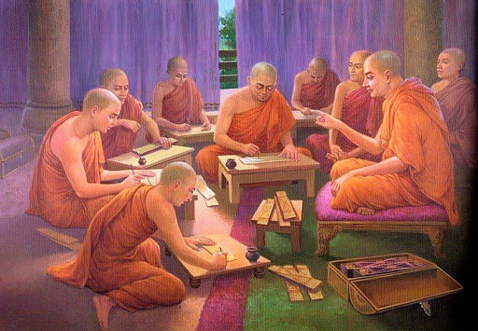
When Buddhism from Sri Lanka had spread to various lands in South-east Asian countries such as Mon, Burma(Myanmar), Siam(Thailand), Laos, and Cambodia, those countries also adopted the Simhalese Pali Tipitaka by successive copying in their own scripts in their respective languages. This tradition was followed and handed down by many Buddhist Countries since the 4th Buddhist Century up to 23rd Buddhist Century. Tipitaka had handed down by manuscript written on palmleaves as in Srilanka, Burma (Myanmar), Siamese(Thai), Loas, and Cambodia.
From those Tipitakas they had belonged, Buddha’s teachings were passed down through generations to generations by means of a manuscript-copying. Therefore, the Tipitaka in each country is somewhat different, but mainly the overall content is the same because they had come from the same original source. (Mahamakuttarajavidyalaya . Tipitakasiamrattha, Thai Version. Bangkok: Mahamakuttarajavidyalaya Press. 2559.p.5).
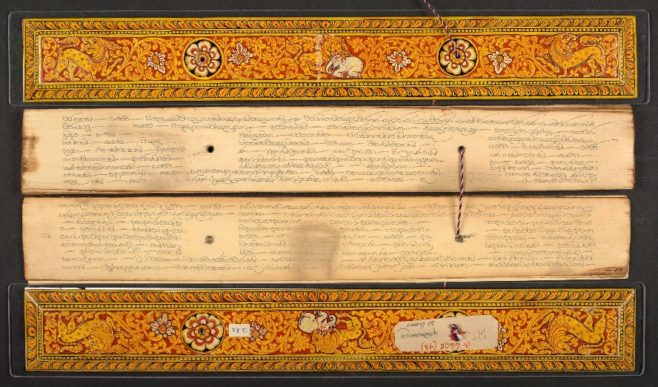
- The Stone Inscription Tipitakas in Mandaley, Myanmar.
The last capital of the Burmese kingdom, Mandalay was founded in 1857 (B.E. 2390) by King Mindon (reigned 1853-1878). The 5th Buddhist Council was held in Maandaley. The Sangayana, or Buddhist Council, is the most important function of the Buddhist religion. The first Sangayana was held during the first Rains Retreat after the Parinibbana of the Buddha; the texts to be regarded as authentic were determined at this time. There had been three more Sangayanas since, according to the Theravada tradition. The council convened by the great Emperor Asoka, whose missionaries brought Buddhism to Myanmar, probably provided the most inspiration for Mindon. The Fourth Council, the one prior to Mindon's council, was held in Sri Lanka in the first century BC, at the Aluvihara near Matale, for the purpose of writing down the Tipitaka, which up to that time had been passed on orally.
King Mindon himself presided over the Fifth Buddhist Council, during which all the canonical texts were recited and the correct form was established from among any variant readings. The task took more than three years to accomplish, from 1868 to 1871. When the Bhikkhus had completed their great project, the king had all of the Buddhist scriptures, the Tipitaka, engraved on 729 marble plates. It was inscribed on 2 stone plate sides, on the first side the Tipitaka was inscribed in Pali language, Burmese script, on the other side inscribed its translation in Burmese language. Therefore, the Tipitaka was inscribed in 729 plates with 1,428 pages. It was the largest version of the Tipitaka having called the “world’s largest book ”.
The great work accomplished by 2,400 Buddhist scholar monks and the great Lay followers headed by 3 prominent Elders namely Ven.Jagarabhivamsa, Ven. Narindabhijja and Ven.Sumangkalasami who took turns being the chairman of the council. It took 5 months to complete that greate carreer.
The inscribed plats were then housed each in a separate small pagoda about three meters high with a roof to protect the inscriptions from the elements. Each one stone plate was protected by a small stone pavilion. https://curate.nd.edu/show/ft848p61h22 10 Jun,2021).
The small shrines were built around a central pagoda, the Kutho-daw Pagoda, the Pagoda of the Noble Merit. To commemorate the great council, King Mindon crowned the Shwedagon Pagoda in Yangon with a new Hti or spire.(Roger Bischoff, Buddhism in Myanmar A Short History 1996, Https://www.accesstoinsight.org/lib/authors/bischoff /wheel399.html available on 10 Jan 2020.)
The Tipitaka was engraved on 729 stone plates in Kuthodaw Temple, Mandalay.

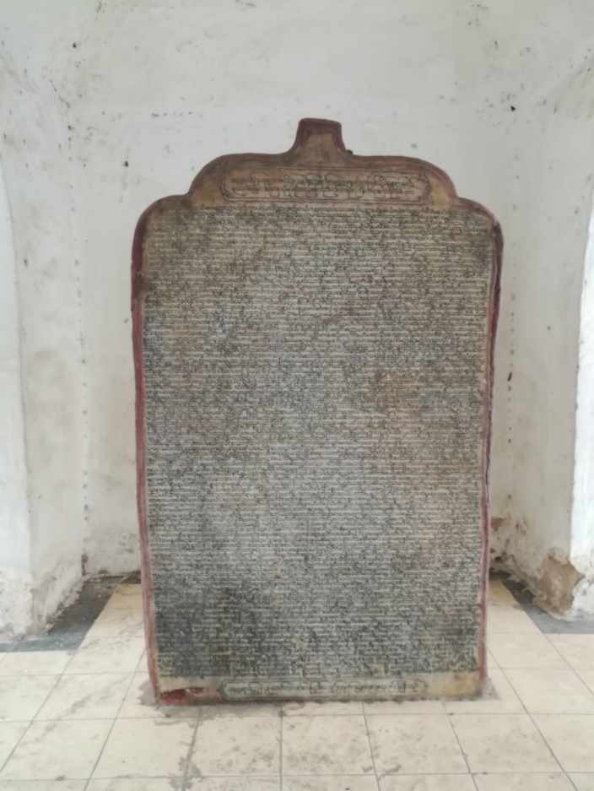
The stone-inscription, Kuthodaw Temple Mandalay (Photoed by Phisit Kotsupho)
1.4 Printing Tipitakas In the form of modern book
Tipitaka had been published in the for of modern books as the followings
1) Thai Version Pali Tipitakas were printed in Thailand (Former Siam) during the time of King Chulalonkorn, Rama the V Kingdom of Thailand during 1889 – 1892 (B.E.2431-2435) for His 25 years of Reign.
For the Tipitaka of Thailand having considered to achieve original form from Sri Lanka since the Sukhothai Kingdom, Some resources may have received through the Mon, Some from Burma and some directly achieved from Sri Lanka at different times. Thai Buddhist had copied the aforementioned scriptures and transliterated into in their own language on palm leaves with Khmer script and passed down through generations in this way.
Until the reign of King Rama V of Rattanakosin, His Majesty King Chulalongkorn, had supported to do the reconciliation of the Tipitaka and transliterate it from the Khmer script into Thai script, then, published the Pali Tipitaka in form of modern book in Thai script. This was the first time that the publication of the Theravada scriptures in Thai script and in the form of the Modern Book, In 1888. In the first printed Tipitaka, only 39 volumes were printed. it was still incomplete leaving 6 volumes namely (1) volume No. 26 Vimanavatthu, Pettavatthu, Theragatha, Therigatha, (2 and 3) volumes No. 27,28 Jatakas, (4) volume no.32. Apadana, (5) Volume No. 33, Apadana, Buddhavamsa Cariyapitaka (6), Volume No. 41 the Patthana.. Finally in reign of King Prajathipok, Rama the VII, all complete set 45 Volumes of Thai Version Pali Tipitaka was printed in 1825-1830 (BE 2468-2473). From those days, Thai Pali Tipitaka has been continuous printed in many times lastly in 2006 (BE 2549) (Mahamakuttarajavidyalaya . Tipitakasiamrattha, Thai Version. Bangkok: Mahamakuttarajavidyalaya Press. 2559.p.(6).

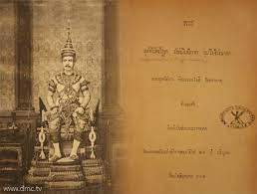

2) Pali Text Society (PTS) https://www.palitext.com/
The Society was founded in 1881 (BE 2424) by Thomas William Rhys Davids "to foster and promote the study of Pāli texts". It publishes Pāli texts in roman characters, translations in English and ancillary works including dictionaries, a concordance, books for students of Pāli and a journal. Most of the classical texts and commentaries have now been edited and many works translated into English. The Society aims to keep almost all its publications in print and to produce at least two new books and a volume of its Journal each year.
The Society is non-profit making and depends on the sale of its publications, on members' subscriptions and on the generosity of donors. Alongside its publishing activities, it provides Research Studentships for a number of people in a variety of countries who are working in the field of Pāli studies.
Sets of the Pāli Canon in English Translation and in Pāli (Tipiṭaka) Pāli Canon in English Translation, Set 33 books in total included: The Book of Analysis,The Book of Discipline 6 Volumes Set, Buddhist Manual of Psychological Ethics, Conditional Relations 2 Volumes Set, Connected Discourses 2 Volumes Set, Designation of Human Types, Discourse on Elements, Dialogues of the Buddha 3 Volumes Set, Elder's Verses 2 Volumes Set, Group of Discourses, 2nd Edition, Jātaka or Stories of the Buddha's former Births 3 Volumes Set, Middle Length Discourses of the Buddha, Minor Anthologies, Vol. III, Minor Readings and the Illustrator of the Ultimate Meaning, Numerical Discourses of the Buddha, The Path of Discrimination, Peta Stories, Points of Controversy,The Udāna and The Itivuttaka,Vimāna Stories,Word of the Doctrine. (T.W.Rhys Davids, Ed. Journal of the Pali Text Society 1910-1912) London: Oxford University Press, 1912. pp.155-158)
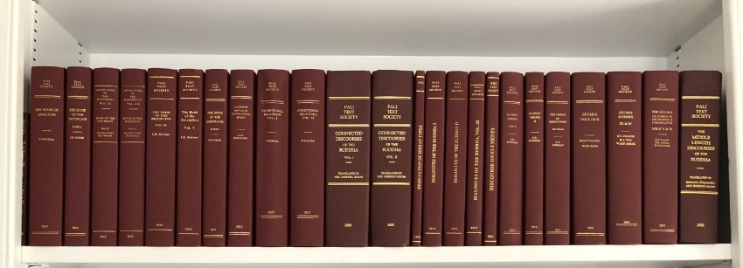
w. Furthermore, the Theravada Buddhist countries such as Myamar, Sri Lanka, Laos, and Cambodia including Devenagri Version of India had their own Tipitaka published in the form of Modern Book the same as Thai.
1.5 The Hard Disk and Compact Disk(CD-Rom) Tipitakas around 25th Buddhist Century
1.5.1 Midol University, Thailand (Program Tipitaka Study) BUDSIR
Academic Buddhist Studies in the Educational Institutions. Computer version of the Pali Tipitaka In 1988, Mahidol University was recorded the Pali Tipitaka scriptures in Thai script into a hard magnetic disk to play on computer. The searcher can search for any word in any book, any page, any lines to show on the screen immediately. It was for the first time in the world that the 45 Pali Tipitaka texts including tens of millions of characters had been transferred into a magnetic Hard Disk and displayed on screen successfully. It was a great honor for Thailand that Asst. Prof. Dr. Supachai Tangwongsan, Director of the Computer Bureau who was the head of the operation committee. It is available on website https://www.mahidol.ac.th/budsir
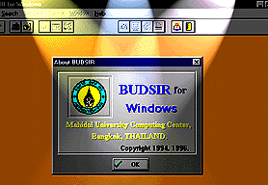
1.5.2 Mahachulalongkornrajavidyalaya University, Tipityaka CD-Rom and Artificial Intelligence, MCUTRI
Mahachulalongkornrajavidyalaya University is an educational institution of higher education that established by His Majesty King Chulalongkorn, Rama V as a institution to study the Tipitaka and higher education for monks, novices and lay people has foreseen the necessity of facilitating the study of the Tipitaka according to the aforementioned royal wishes. Therefore, University had examined and verified Pali Tipikata and translated in to Thai covered all 45 Volumes name as "Pali Tipitaka Mahachulalongkornrajavidyalaya University Version" and "Thai Tipitaka Mahachulalongkornrajavidyalaya University Version sine B.E. 2539.
With foreseeing the benefits of studying and propagating Buddhism by providing academic service to society through modern information technology systems Phra Dhammakosacaraya (Prayoon Dhammacitto), the President of Mahachulalongkornrajavidyalaya University had run a project to develop a database system for searching Tipitaka Mahachulalongkornrajavidyalaya University Version on CD-ROM and distributed on CD-ROM which can be used effectively with a general PC computer. The Mahachulalongkornrajvidyalaya University Tipitaka Retrieving Artificial Intelligence CD-ROM, MCUTRAI contained 45 volumes in to 2 CD-ROM discs; Disc No.1. contains a content about the evolution of the Tipitaka, the meaning, importance, and development of the Tipitaka from India to Thailand via contemporary multimedia media and Disc No.2. contents Thai Tipitaka Mahachulalongkornrajavidyalaya University version covered 45 volumes with a fully searching system in B.E 2551(2008).
It is available on website http://oldweb.mcu.ac.th/mcutrai/index.htm as below shown.
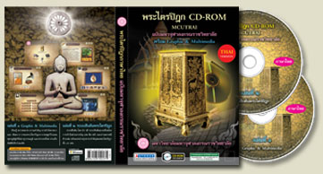
http://oldweb.mcu.ac.th/mcutrai/index.htm
1.6 Recently, the Online Tipitakas
In this digital age, Tipitaka is posted on line by many website domains. Any one needs to find any topic, any content or whatever needed from Tipitaka, he/she can search with the help of search engines, then get it effectively. The followings are the examples of Online Tipitakas posted by Websites in online networks:
1.6.1 https://tipitaka.org : The Pāḷi Tipiṭaka is now available online in various scripts. Although all are in Unicode fonts, you may need to install some fonts and make some changes to your system to view the site correctly. Tipiṭaka Scripts are posted in Cyrillic Web, Devanagari Web | PDF, Gujarati Web, Kannada Web, Malayalam Web, Roman Web | PDF ,Tamil Web ,Telugu Web, Other Scripts such as Bengali, Gurmukhi, Khmer, Myanmar, Sinhala, Thai, Tibetan.
1.6.2 www.84000.org: This website provides online titipitaka in Thai Pali Tipitaka Version, PALI ROMAN, Thai Translations, English Tanslation, Comentaries both in Pali and Thai Translation, and Romanized Script.
1.6.3 http://www.kbrl.gov.mm : 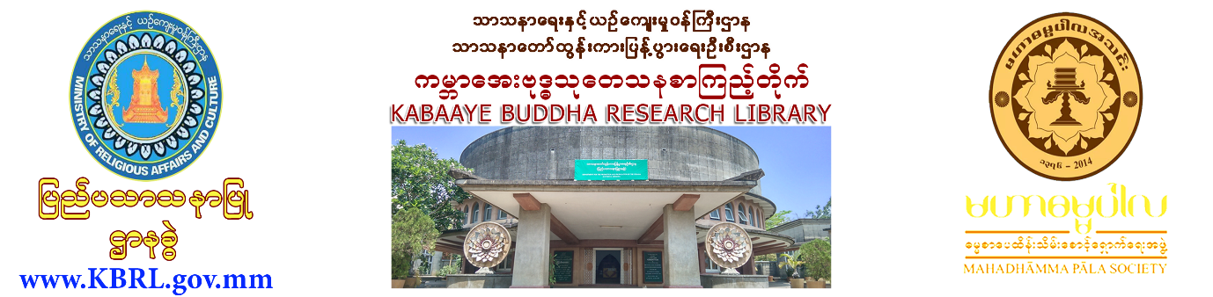

1.6.4 https://store.pariyatti.org/Video-Streaming-and-Downloads_c_611.html
2. A.I.Technology for human facilitation
2.1 What is A.I. Technology ?
The artificial intelligence is the theory and development of computer programs that are able to do tasks and solve problems that usually require human intelligence. Things like visual perception, speech recognition, decision-making, and word translation are all things that would normally need human intelligence, but now computer programs are able use their intelligence and capability to solve these tasks. Artificial intelligence is a technological advancement that involves programming technology to problem solve. Artificial intelligence is often talked about in conjunction with machine learning or deep learning and big data.
This type of intelligence was born in June of 1965 where a group of scientists and mathematicians met at Dartmouth to discuss the idea of a computer that could actually think. https://www.wgu.edu/blog/what-ai-technology-how-used2003.html#close
2.2 Development and Applied A.I. to workplace.
In the beginning, A.I. works for man like robots in the industry. They have been preprogramed to work and work according to software programs created by programmers. Nowadays, A.I.Technology was controlled in the humanized robots and order robot work like real human. Those robots can walk, talk, think and response towards arousing objects.
2.3 A.I. Announcers from China (Humanoid Robot / look like Human https://www.youtube.com/watch?v=HJcdVjkqiW8
China’s Xinhua state news agency has introduced the newest members of its newsroom: AI anchors who will report 'tirelessly' all day, every day, from anywhere in the country Subscribe to Guardian News on YouTube.
China's Xinhua state news agency on Sunday used a lifelike robotic news anchor that mimics human facial expressions and mannerisms to present a story about delegates attending an annual parliament meeting arriving in Beijing. The artificial intelligence robot named "Xin Xiaomeng" sported a short haircut and wore a pink blouse and earrings in a one-minute video presentation by Xinhua.
2.4 A.I. Robot gets Saudi Arabian Citizen Miss Sophia https://www.youtube.com /watch?v =ZQrKFAAlxO4
In 2017, social robot Sophia was given citizenship of Saudi Arabia – the first robot to be given legal personhood anywhere in the world. Bestowed with this great gift, Sophia has embarked on a distinguished career in marketing.
Sophia’s creator, David Hanson, argues that the opportunity was used to “speak out on women’s rights”, a statement that sits somewhat awkwardly in Saudi Arabia, a country in which women have only just been given the right to drive and where “male guardianship” still exists, meaning many women have to ask permission from male relatives or partners to leave the house, get a passport, get married or even file police reports for domestic violence or sexual assault. The citizenship stunt seemed more akin to a marketing campaign – for Sophia and Saudi Arabia – than it did a genuine statement on humanity, dignity or personhood.
https://www.wired.co.uk/article/sophia-robot-citizen-womens-rights-detriot-become-human-hanson-robotics available on 11-4-2020.
2.5 A.I. Buddha /Japan
In Japan a spiritual robot is making the teachings of Buddha more easily understandable. Preaching in the Kodaiji Temple in Kyoto, the aluminum and silicone robot priest stands almost two metres tall. Its creators hope it will encourage people to take more of an interest in Buddhism.
A new priest named Mindar is holding forth at Kodaiji, a 400-year-old Buddhist temple in Kyoto, Japan. Like other clergy members, this priest can deliver sermons and move around to interface with worshippers. But Mindar comes with some ... unusual traits. A body made of aluminum and silicone, for starters.
“This robot will never die; it will just keep updating itself and evolving,” said Tensho Goto, the temple’s chief steward. “With AI, we hope it will grow in wisdom to help people overcome even the most difficult troubles. It’s changing Buddhism.”
https://www.vox.com/future-perfect/2019/9/9/20851753/ai-religion-robot-priest-mindar-buddhism-christianity and https://www.youtube.com/watch?v=_XdQugsDz8E Mar 15, 2019.
Robots are changing other religions, too. In 2017, Indians rolled out a robot that performs the Hindu aarti ritual, which involves moving a light round and round in front of a deity. That same year, in honor of the Protestant Reformation’s 500th anniversary, Germany’s Protestant Church created a robot called BlessU-2. It gave preprogrammed blessings to over 10,000 people.
3. Buddhist Guide for Moral Teaching Based on Tipitaka
3.1 Purposes of Project
The Foundation for Study and Propagation of Buddhism in the Region of Mekong River MCU.CM, has set the project to help people in searching the teachings of the Buddha whatever they need originally from Tipitaka either in Thai version or English version those had been translate by the Pali Text Society(PTS). This means that if they want to know for instance the five precepts, where is the teaching of five precepts appeared on which page of which volume in MCU Tipitaka, at the same manner, it should be mutually searched from English Pitaka Published by PTS. It was run under the “International Reproduction and Distribution of Tipitaka For Buddhism Education and Propagation” project of The Foundation for Study and Propagation of Buddhism in the Region of Mae Khong River
Mahachulalongkornrajavidyalaya University (MCU), Chiang Mai Campus
3.2 The Scope of Activities
The following Buddhist Guide for Moral Teaching based on the Tipitaka references sermons that are relevant to the Tipitaka, with the purpose of developing teachings that can be utilized in a communal setting, thereby “giving life” to the Tipitaka.
There are 3 methods of teaching morality based on the Tipitaka:
Providing lectures and sermons, which include contents that reflect the discussed topic, as well as questions that connect doctrine with practices within the Tipitaka for conceptual understanding.
Organizing communal activities that promote teachings
Evaluating and concluding activities for further improvement and development
Each activity plan within this guide is comprised of the following components:
Order of sorting, which includes:
Unit – Organized according to the Three Jewels of Buddhism (Buddha, Dhamma, Sangha)
Category – Moral principles that appear within each unit
Section – Teachings that are relevant to the category
Topic – Certain teachings and principles that is relevant with a particular aspect of life, as discussed by the Tipitaka
Purpose – The direction or expectation for activity participants to consider for developing knowledge, understanding and practice
Synopsis – Summary of main points and contents within the activity
Activity – Detailed plan and guide towards practicing its purpose, which includes lectures, sermons (referenced from the Tipitaka) and narrations, as well as questions, media, tools, and evaluations
Results – Expected outcomes from organizing the activity
3.3 The Scope of Resources and Contents
The resources are Tipitaka both in Thai and English versions. The table of the Doctrinal References in Tipitaka, MCU Thai Version compared to Pali Text Society (PTS) Tipitaka English Version, MCU, CM Campus,Wat Suan Dok, Chiang Mai. The project has set the topics according to the Triple gems; the Buddha in 71 topics, the Dhamma in 267 topics and the Sangha in 10 topics as shown below:
3.4 The Present Point Performance.

Teaching framework for moral teaching based on the Tipitaka
Unit | Category | Section | Activity Plan/Topic
Buddha | The Buddha | The Buddha before enlightenment | 101. Birth and Early Life of the Buddha  102. Understanding Suffering  103. The Buddha’s Ordination
 |  | The Buddha after enlightenment | 104. The Buddha’s Enlightenment  105. The Buddha’s Teachings  106. The Buddha’s Death and Attainment of Nirvana
 |  | The Buddha during performing meritorious acts | 107. The Buddha’s performing meritorious acts
Dhamma | Abstaining from sin | Common people | 201. The Five Moral Precepts  202. Refraining from the Six Vice  203. Avoiding the Four False Friends  204. Refraining from the Four Prejudices  205. Refraining from the 5 Immoral Business Practices
 | Doing good | Common people | 206. Refuge in The Three Jewels  207. The Four Virtues for the Present  208. The Four True Friends  209. Making Merit to the Six Directions  210. The Four Principles of Service  211. The Four Principles of A Good Household Life  212. The Five Principles of Managing Wealth  213. The Four Principles of Family Prosperity
 | Purifying the soul | Common people | 214. The Five Doctrines for the Prosperity of Followers  215. The Four Principles for Approaching Difficult Fulfilling Goals  216. The Four Principles for Future Prosperity and Benefit  217. The Four Principles of Attaining Happiness for the Follower
 | Abstaining from sin | Trustworthy people | 218. Abstaining From The Five Unjust Deeds  219. Maintaining the Holy Moral Precepts  220. Understanding, Determining, and Refraining from Devices of Suffering
 | Doing good | Trustworthy people | 221. Developing the 5 Trustworthy Doctrines  222. The 10 Methods of Creating Merit  223. The 10 Mindful Recollections  224. The 7 Doctrines for Communal Stability
 | Purifying the soul | Trustworthy people | 225. The 2 Components for Correcting Understanding  226. The 4 Attitudes Towards Others  227. Developing the 38 Good Omens  228. Contemplating the 5 Norms  229. Contemplating the Three Marks of Existence  230. Developing the 7 Prognostications of the Noble Path
Sangha | The duties of a Buddhist | Being a faithful member of Buddhism | 301. Practicing the Teachings of the Buddha  302. The Preservation of Buddhist Ceremonies

Activity Plan No. 101 – Birth and Early Life of the Buddha

Unit | Buddha
Category | The Buddha
Section | The Buddha before enlightenment
Topic | Birth and Early Life of the Buddha
Purpose
To learn about the life of an important figure of the world, from his birth into royal status abundant with comfort, wealth and pleasure, as well as a loving family, and highlight his boredom from happiness in the physical world encompassed by suffering and temporality.
To understand the truth regarding happiness in the physical world that all seek to attain, in which it possesses sever consequences that hold back the development and liberation of humanity from suffering, remaining endlessly in the Samsara cycle.
To raise awareness about the consequences of sensual desires which trap an individual in Samsara cycle, creating wisdom and rightful thinking.
Synopsis
According to traditional sources, the Buddha was a deity of the Tusita realm, named the Bodhisattva Svetaketu, before his mortal conception. He was born into a Hindu ruling family as the son of Suddhodana, ruler of the Shakya clan (located in modern day India, Nepal, Bangladesh, Pakistan, and Bhutan), and his wife Mayadevi.
The Buddha was born in the gardens of Lumbhini (modern day Nepal), between the city-states of Kapilavastu and Devadaha, underneath a sal tree. His mother did not feel pain during labor, and after his birth he walked 7 steps, proclaiming “I am the noble one, the wise one, the elegant one of the universe, and this shall be my last life as I am now free from the cycle of life.”
Later on, 8 brahmans provided a prophecy to Suddhodana that his son would either become a great king or a great holy man, though one brahman (Kaudinya, who would later become the first member of the Sangha) instead prophesized that he would be become the enlightened one, or the Buddha. The child was given the name “Siddhartha”, meaning “he who achieves his aims”. 7 days after Siddhartha’s birth, his mother Mayadevi passed away, and was reincarnated as a deity of the Tusita realm.
Later, when Siddhartha initiated his first practice of meditation under a java plum tree, it was as if time stood still; though it was during the afternoon, the plum tree did not lean towards the sun’s direction. This amazed Suddhodana, who praised his son and such occurrence.
As Siddhartha grew older, he studied up to 18 subjects’ arts and practices under skilled mentors, of which he was able to complete rapidly. Siddhartha married his cousin Yasodhara at age 16, and at age 29 she gave birth to his only son, whom he named Rahula, meaning fetter. This was because when Rahula was born, Siddhartha proclaimed, “Another fetter has been bestowed onto me”.

Activities
Sermons with Sutrapitaka (Publisher.name of Sutrapataka or Title volume/section/page) | PTS.Middle Length Discourses of the Buddha / Majjhima-nikāya / part No. 3 Uparipannasapali: the final fifty discourses 123 AcchariyaAbbhutaSutta, (entry No.) 1-23, pp.979-984 : The Buddha’s life since the transmigration from Tusita Heaven to his birth  PTS.Numerical Discourses of the Buddha / Aṅguttara-nikāya :The Book of Gradual Sayings, the book of one, XIII(13) One Person, (entry No.) 170(1)-187(18), pp.107-108 : The miracle of the Buddha  PTS.Dialogues of the Buddha Vol.2 / Dīgha-nikāya Volume 2, No. of Sutta 14 MahapadanaSutta, The Sublime Story (entry No.) 17(12) -30, pp. 8-13 : The 16 Natural Laws of the Bodhisatta; the Next to be Buddha  PTS.Dialogues of the Buddha Vol.3/ Dīgha-nikāya,  XXX(30), Lakkhanasuttanta, The Marks of Superman, (entry No.) 142-162, pp.137-153 : The 32 Characteristics of the Great One and the past deeds caused of achievement and the 32 Characteristics of the Great One  PTS.Middle Length Discourses of the Buddha / Majjhimanikāya Majjhimapannapali. Part 2  Sutta No.75 MagandhiyaSutta, To Magandhiya, (entry No.) 1-28, pp.607-617 : The Buddha spoke to Magandhiya, a Brahmin, about the Sensual Pleasure, the passion in sesual pleasure, the free form it, because of the arising of the boredom in the householder life.  PTS.Middle Length Discourses of the Buddha / Majjhima-nikāya Mulapannasapali Part 1,  Division 2, Sutta No.13 MahadukkhakhandaSutta, The Greater Discourse on the Mass of Suffering, (entry No.) 7-17, pp. 179-183 : The profit, blemish and the renunciation from the sensual pleasure  (The reader can study more related sermons/Dhamma contents from Tipitaka and other documents suggested for using with this book)
1) Narrate the story of the Buddha’s early life, explaining his comfortable status with prestige and power, unlikely to cause disinterest and displeasement.
2) Narrate Siddhartha’s disinterest in his comfort and leisure. When Siddhartha left to become a holy man, he passed by the palace chambers, where he witnessed the disgusting state of the concubines and dancers sleeping, to which he remarked, “This is discord, this is troublesome.”
Questions to audience | What was the Buddha’s name before enlightenment? What was his previous life? Who were his family?  Why does one think that Siddhartha became disinterested in his pleasures and comfort?  Why does one think Siddhartha wanted to ordain?
Tools to use in activities | The diagram “what the Buddha teach people”  Tipitaka  Other beneficial tools
Evaluation | Mentors  Interviewing about the effects of the activities based on the purpose.  Participants  Volunteered evaluation  Inspection of volunteers  Asking participants about the knowledge gained

Results
Mentors can study and understand the Buddha’s early life and how to use this in activities.
Volunteers are involved in organizing activities related to studying the Buddha’s early life.
Participants have a better understanding of the Buddha’s early life.
More participants become involved in Buddhist-related activities.
Participants study the Buddha’s early life. (The Foundation for Study and Propagation of Buddhism in the Region of Mae Khong River, Buddhist Guide for Moral Teaching based on the Tipitaka, Chiang Mai : International Reproduction and Distribution of Tripitaka For Buddhism Education and Propagation, 2021. pp.5-8.
4. Conclusion
In the AI age it is very easy to find out all the concerned knowledge via internet and search engine. The thing that all searchers have to keep in mind that they have to investigate analyze and evaluate the trustworthy sources, so that the true data or information posted by reliable sources shall be helpful and practicable. In study Tipitaka, the Buddhist Text in this day, we call comparative study the same content from other languages or other editions from Buddhist organizations. Let say for MCU CM campus, we have run the English Tipitaka study program for foreigners who come to chat with our monks in university. If we prepare the guideline of Dhamma and the text references correctly, it will be interesting and more rational to one who come for study the Buddha’s teachings from the real sources from the Pali canon.

Reference
Bapas P.V. 2500 Years of Buddhism. New Delhi : Publications Division, Ministry of information and Broadcasting, Government of India, 1956.
Http://oldweb.mcu.ac.th/mcutrai/index.htm available on 20- 1-2020.
Https://www.accesstoinsight.org/lib/authors/bischoff /wheel399.html available on 10 Jan 2020.)
Https://www.mahidol.ac.th/budsir available on 15-1-2020.
Https://www.palitext.com/ available on 11-4-2021.
Https://www.vox.com/future-perfect/2019/9/9/20851753/ai-religion-robot-priest-mindar-buddhism-christianity available on 25-4-2020.
Https://www.wired.co.uk/article/sophia-robot-citizen-womens-rights-detriot-become-human-hanson-robotics available on 1-1-2020.
Https://www.youtube.com /watch?v =ZQrKFAAlxO4 available on 9-4-2020.
Https://www.youtube.com/watch?v=HJcdVjkqiW8 available on 11-4-2020.
Mahachulalongkornrajavidyalaya. Tipitaka, Mahachula Version (Pali). Bangkok : Mahachulalongkornrajavidyalaya Press. B.E.2535.
Mahachulalongkornrajavidyalaya. Tipitaka, Mahachula Version (Thai). Bangkok : Mahachulalongkornrajavidyalaya Press. B.E.2539.
Mahamakuttarajavidyalaya. Tipitaka, Siamrattha Version(Pali). Bangkok : Mahamakuttarajavidyalaya Press. B.E.2523.
Panyasami. Sasanavamsa. Bangkok: Fine Arts Department, BE 2506
T.W.Rhys Davids, Ed. Journal of the Pali Text Society 1910-1912. London: Oxford University Press, 1912.
The Foundation for Study and Propagation of Buddhism in the Region of Mae Khong River, Buddhist Guide for Moral Teaching based on the Tipitaka, Chiang Mai : International Reproduction and Distribution of Tripitaka For Buddhism Education and Propagation, 2021.
The Pali Text Society. Dīgha-nikāya : Dialogues of the Buddha Vol II, the 4th Edition. Mahaparinibbanasutta, Pristol: The Pali Text Society. 2013.

